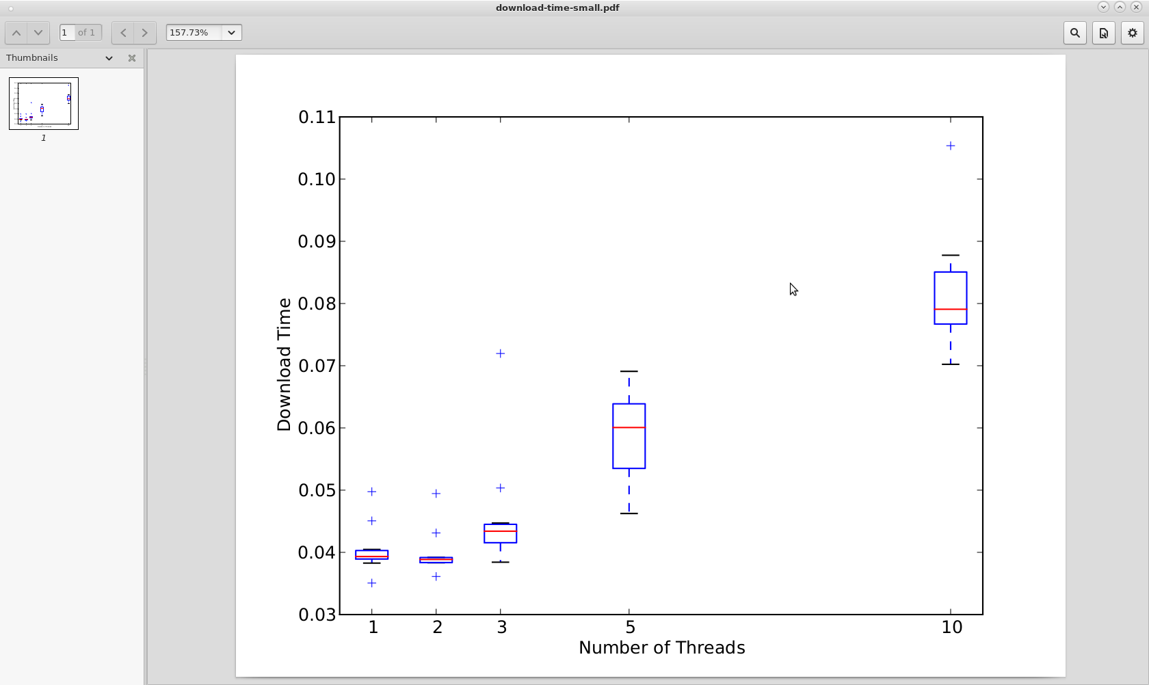
Download Graphs On-Campus:

Small Fig 1:

Medium Fig 2:
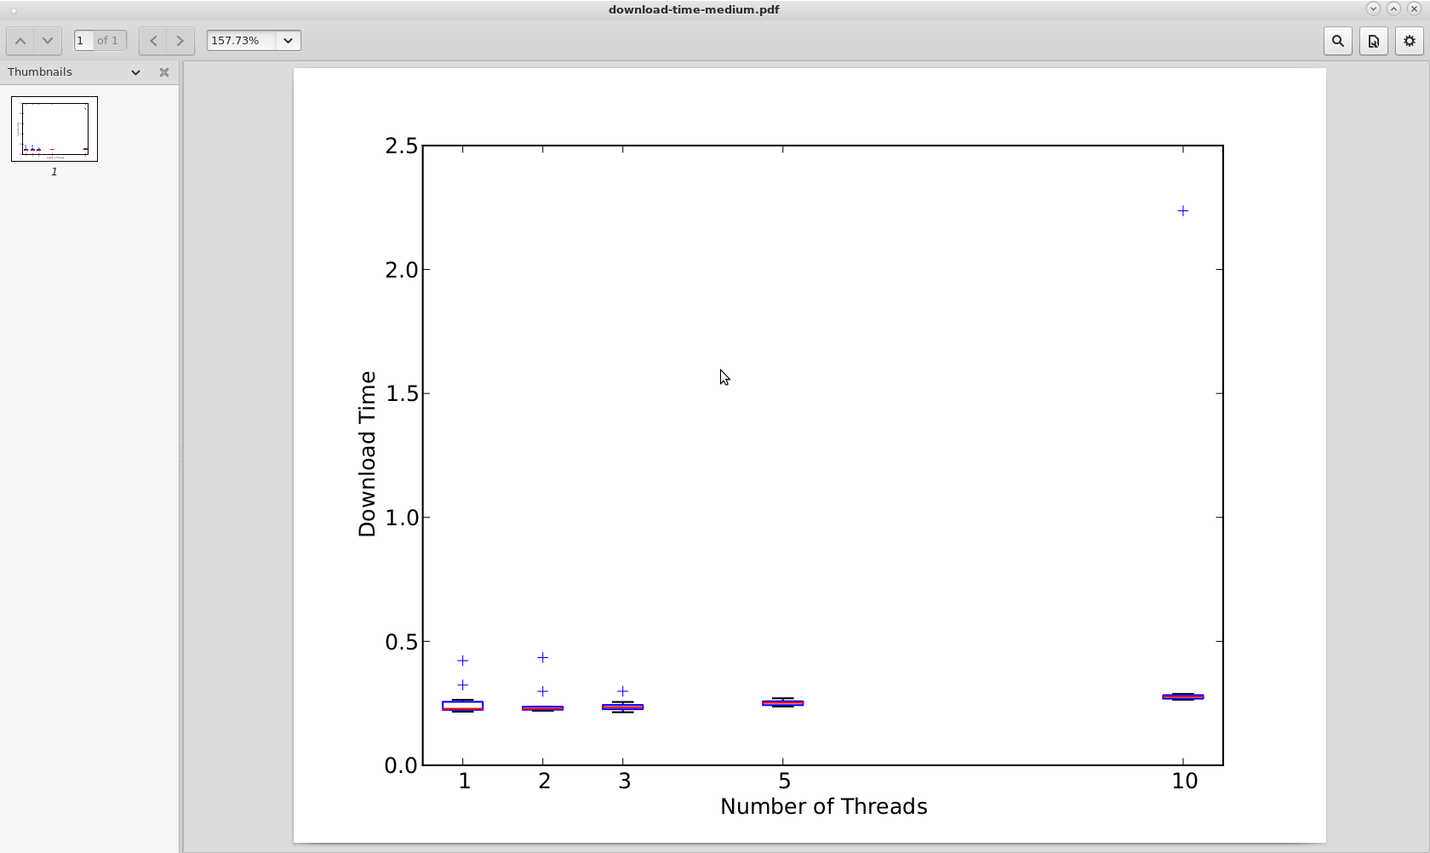
Large Fig 3:
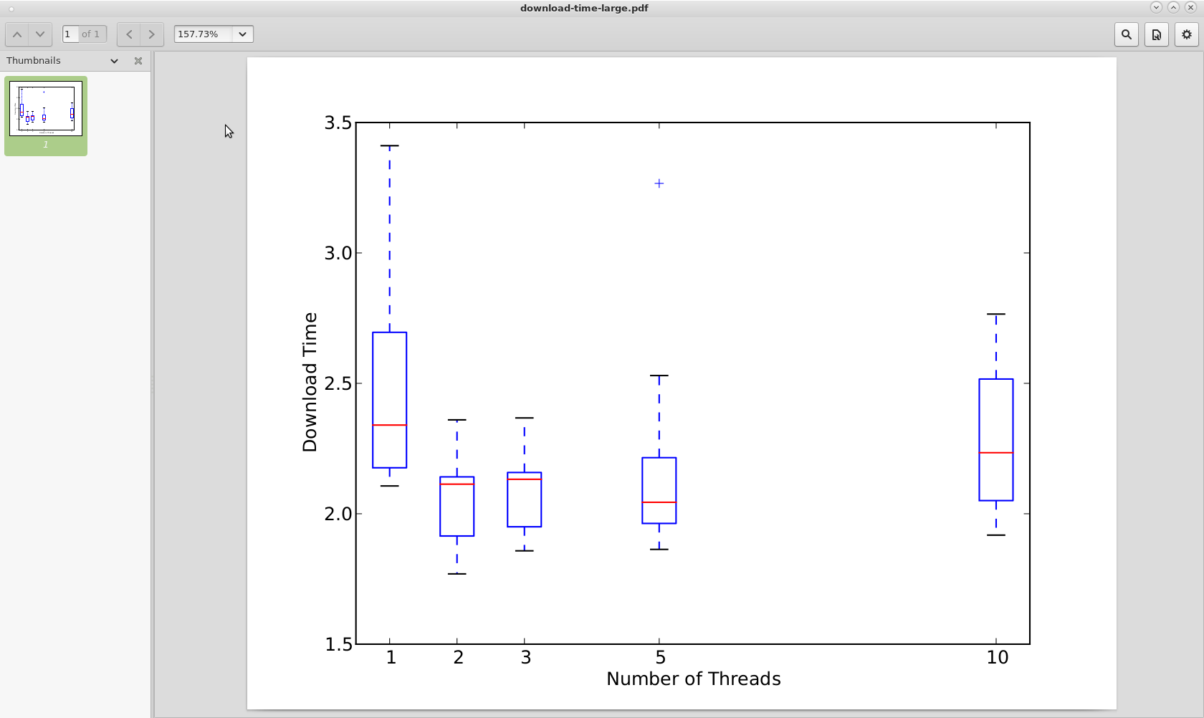

Downloads Graphs Off-Campus:

Small Fig 4:
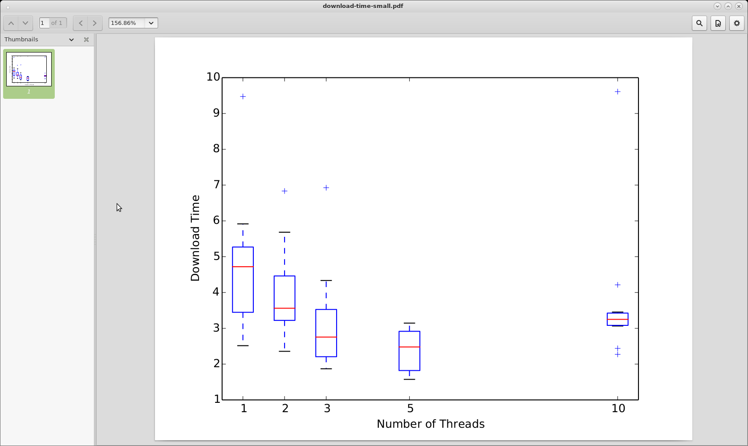
Medium Fig 5:

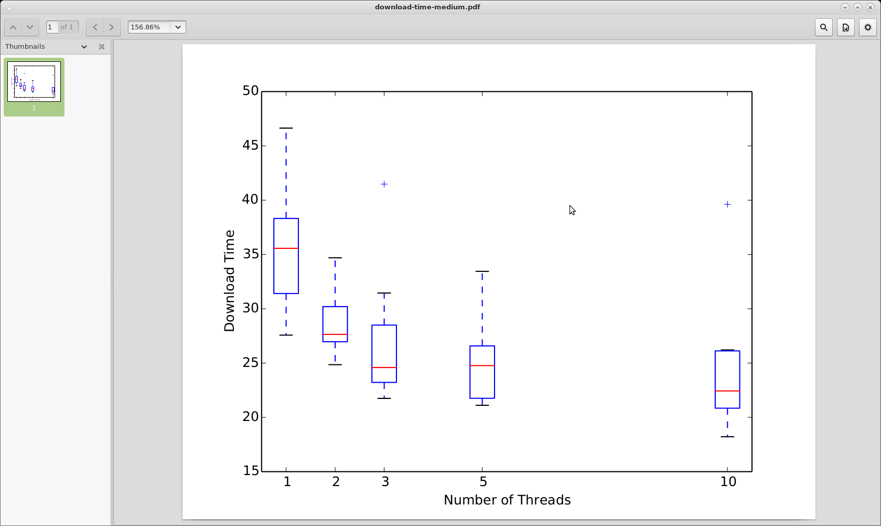

Methodology

In order to collect data for my downloader, it was first necessary to write my downloadAccelerator. After writing this script I was able to use the provided experiments.py and plot.py to gather data on download times given variable numbers of threads. I ran the experiments in the Weapons Lab in the basement of the Talmage building (Fig. 1-3) and then compared those results with data returned when running the experiments on my laptop at home (Fig. 4-5).

Results

After analyzing my results there were several things I learned. First, if we look at Fig. 1 we see that the download time for downloading the “small” file (1 MB) on-campus increases with an increasing number of threads. This shows that if the file is small enough, more threads actually hurts your download time. This is because breaking the file into lots of small chunks, downloading, and then recombining is slower than letting one thread handle the whole small file. This is supported by Fig. 4. Downloading the small file at home on my laptop displayed a similar behavior with one difference. Off-campus, increasing the number of threads helped the download speed to a point (5 threads) but downloading with 10 threads took longer like we saw in Fig. 1.

The second thing we can see from these results is that your connection is more important than the number of threads you use to download. In Fig. 2 and Fig. 3 the mean download times are really close, especially in Fig. 2, no matter the number of threads. This shows that if one thread can download at the full link speed it will be roughly equivalent to the speed of downloading with multiple threads and therefore multiple threads will be of no benefit.
Finally, Fig. 5 shows that if you download with a connection where one thread doesn't use the full link speed, then increasing the number of threads can give you a speed up on download time. In Fig. 5 as you increase the number of threads the download time decreases.

